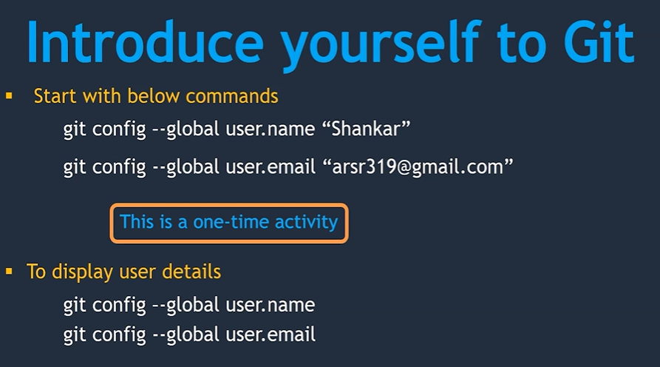

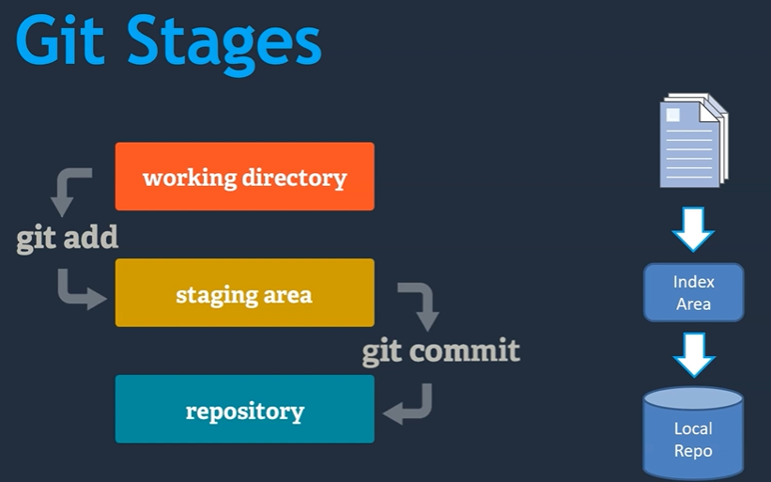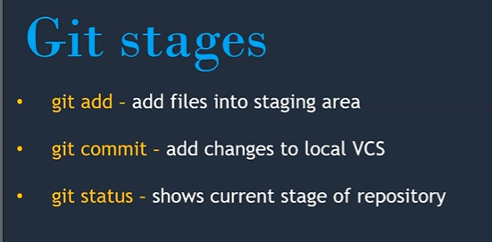

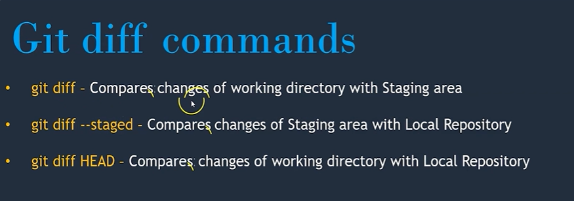

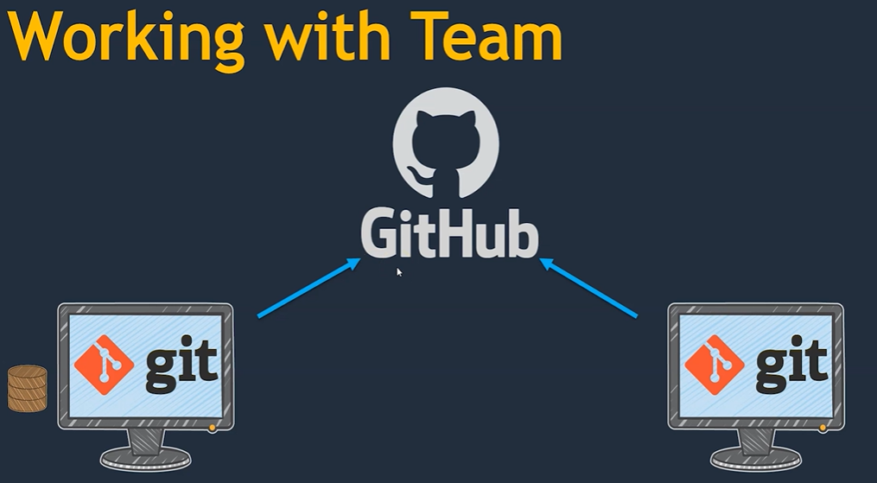

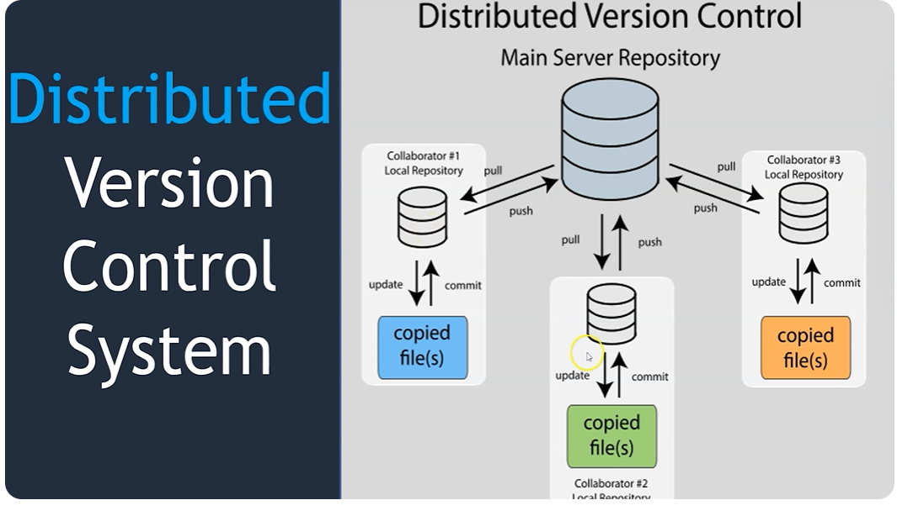

[jayesh271184](https://github.com/jayesh271184)/**[dhtechlab](https://github.com/jayesh271184/dhtechlab) : J@yesh2711**

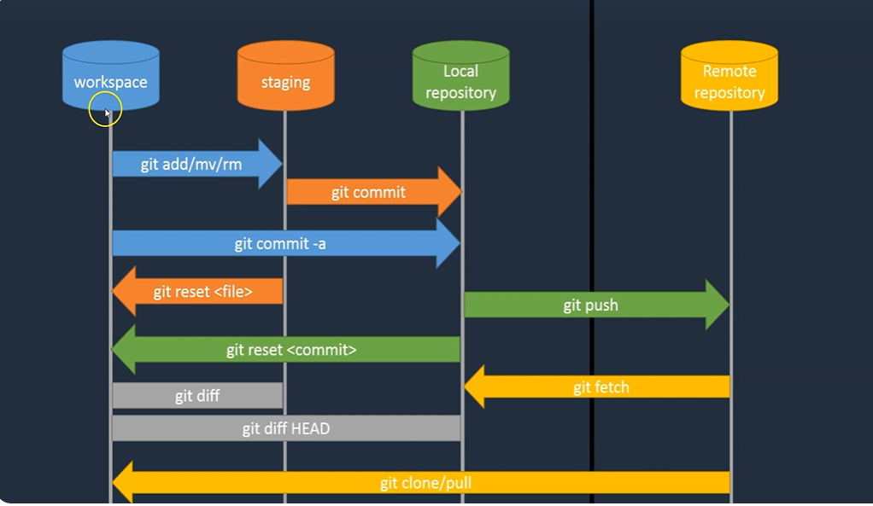

git clone https://<URL of Remote repo (Copy the Repo to local Repo)

git push origin <repo Master/main> (Push the change to Remote repo from Local origin)

git push origin main:branch1 (Push the changes to Remote repo sub branch from Local origin)

git pull ( This will pull the changes if already repo clone is present in local system)

git annotate <FileName> (This will show the changes done on particular file in all the commits)

git show <commit ID> (This will give you changes in given commit ID)

git branch <BranchName> (It will create New Branch with given Name)

git checkout <Commit ID> (It will move to previous commit point for Main or Master)

git checkout <Branch name> (It will switch the default branch from Main to Given Branch)

git merge <Branch to be merge> (This will add branch to current Branch )

Connecting Git hub using SSH key

=============================

1. Generate key using Linux commands

ssh-keygen (id_rsa, id_rsa.pub under /root/.ssh/ )

1. Start SSH agent by below command :

eval $(ssh-agent -s)

1. Copy ssh public key to git hub account at below path :

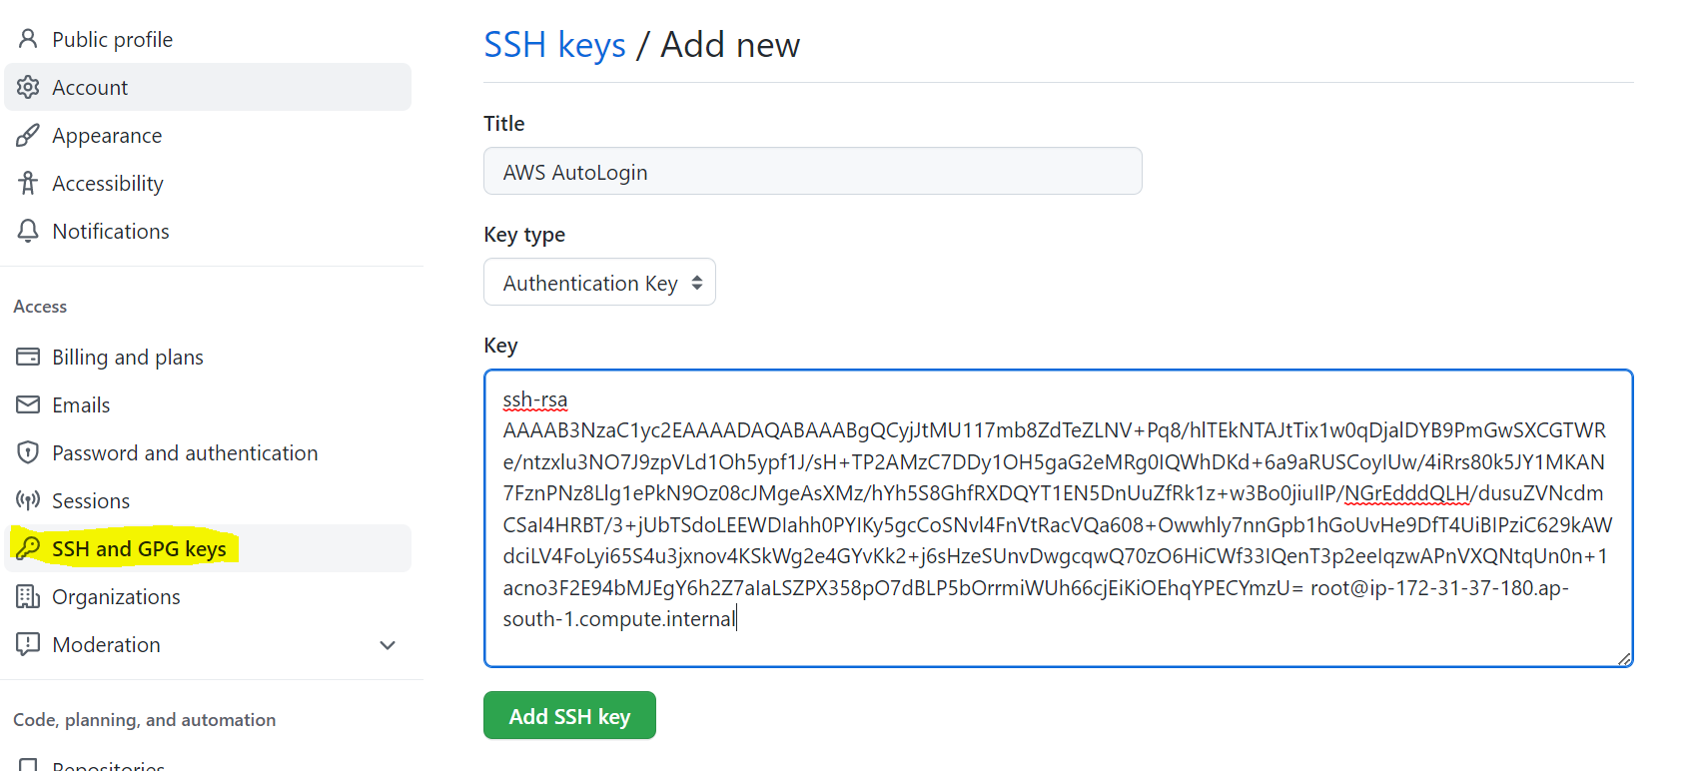

Map Local repo with git hub or Remote Repo

====================================

1. Create Same Name Repo on Git hub
2. Use below Command

git remote add origin git@github.com:jayesh271184/Demo.git

git branch -M main

git push -u origin main

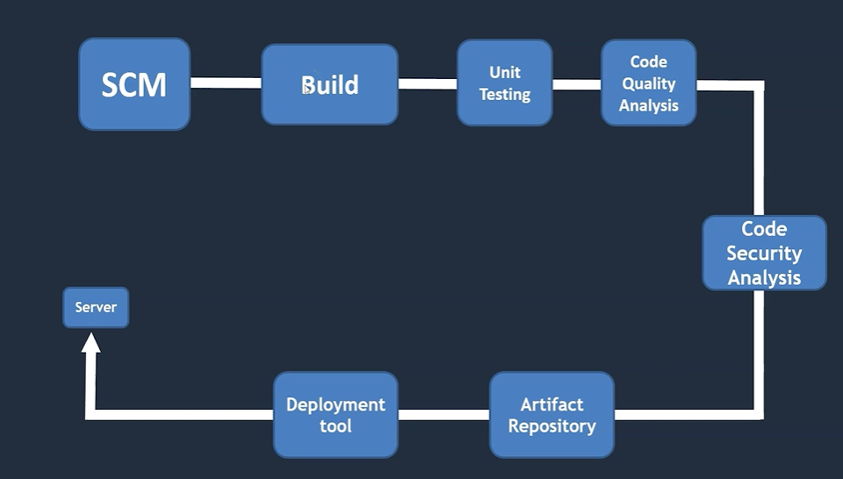

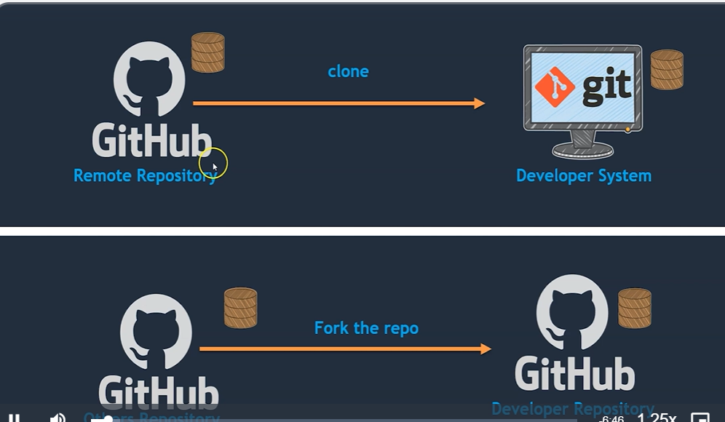

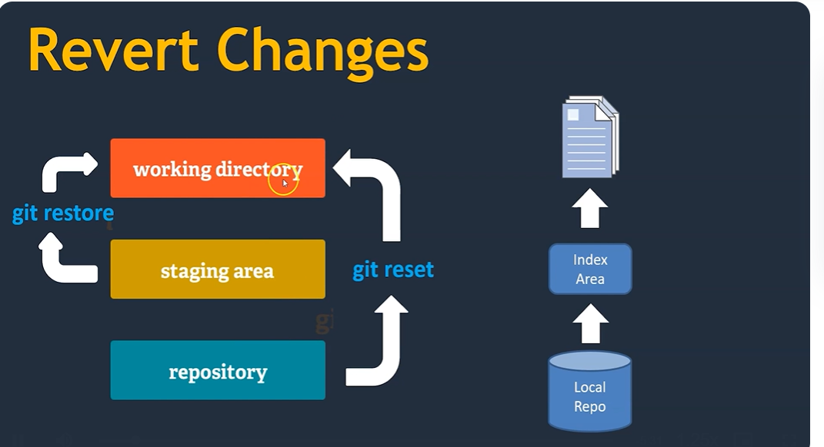

git restore <filename>

git checkout -- <filename> (This will help to restore file in working area)

git restore -- staged <Filename> (This will help to restored file in Staging Area or index dir)

git reset HEAD^1 (it will reset to Local Repo with last Commit ID)

vi .gitignore (This file will used to ignore the file which don’t want to add in repository)

